

**MATHEMATICS  
Methods Units 1 & 2**

**Test 1 – Trigonometry**

**Chapters 11, 12 and 13**

**Semester 1 2019**

# 

**Section Two - Calculator Assumed**

Time allowed for this section

Working time for this section: 30 minutes

Marks available: 31 marks

## Material required/recommended for this section

##### To be provided by the supervisor

This Question/Answer booklet

Formula sheet

##### To be provided by the candidate

Standard items: pens, pencils, pencil sharpener, eraser, correction fluid, ruler, highlighters

Special items: drawing instruments, templates, notes on one unfolded sheet of A4 paper, and up to three calculators satisfying the conditions set by the Curriculum Council for this course.

## Important note to candidates

No other items may be used in this section of the examination. It is **your** responsibility to ensure that you do not have any unauthorised notes or other items of a non-personal nature in the examination room. If you have any unauthorised material with you, hand it to the supervisor **before** reading any further.

1. (6 marks)

Evaluate x correct to one decimal place.

1. 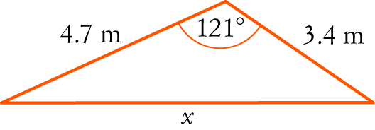 [3]
2. 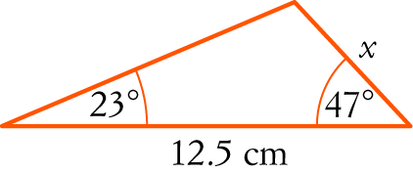 [3]
3. (3 marks)

Calculate the smallest possible length of AB in the triangle shown below.

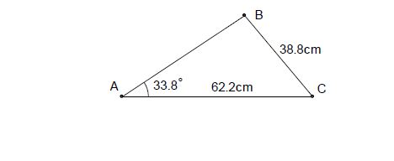 *(The triangle is not drawn to scale).*

1. (9 marks)

Two circles, one of radius 8cm and the other of radius 18cm, with a common tangent, touch each other as shown in the diagram.

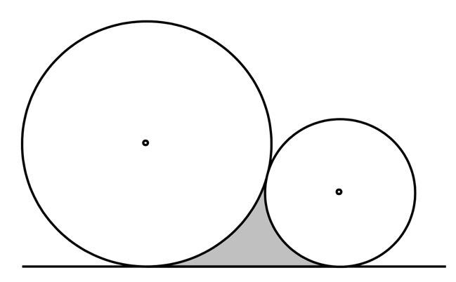

1. Calculate the perimeter of the shaded region. [5]
2. Calculate the area of the shaded region. [4]
3. (3 marks)  
   In the diagram below (not to scale), the line AC intersects the line BD at O. The angle AOB=35o, and the lengths OB=14cm, OD=26cm and AC=30cm. If the area of triangle ODC is twice that of triangle OAB, determine the length OA.

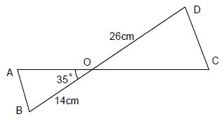

1. (4 marks)

In the quadrilateral ABCD, AB = 6cm, BC = 7cm, AD = 12cm, and ABC = 120°, angle ACD = 70°. Calculate the size of angle ADC. Give your answer to 2 decimals.

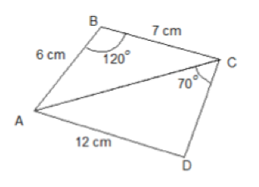

1. (3 marks)

The diagram shows a sector of a circle with centre O. The radius of the circle is 8 cm. PRS is an arc of the circle. PS is a chord of the circle. Angle POS = radians

Calculate the area of the shaded segment. Give your answer correct to 3 significant figures.



1. (3 marks)

The diagram shows a sector of a circle with centre O. The radius of the circle is 6 cm and angle AOB = 120°. Find the arc length AB in terms of π.



**End of Test**